Ec2 tash

1 . Launch one EC2 using Amazon Linux 2 image and add a script in user data to install Apache.
Create a instance
#!/bin/bash
sudo yum update -y
sudo yum install httpd -y
sudo systemctl start httpd
sudo systemctl enable httpd
Added user data
( syntax)
Connect the remote connection
Ssh -I pem ec2-user@

Systemctl status httpd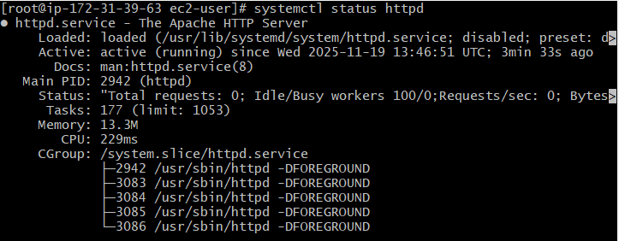

Go to website and check with pIP
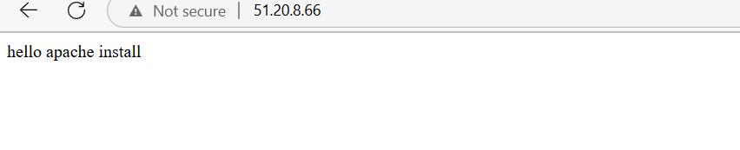

2.Launch one EC2 using Ubuntu image and add a script in user data to install Nginx.
Create the instance
Add the user date
Check the website with ip
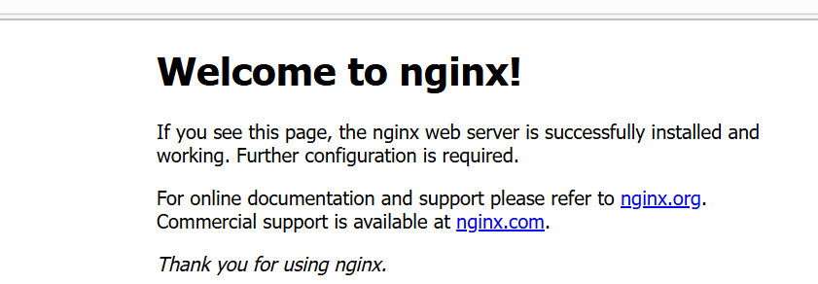

Go to ec2 dashboard
◊AMI : Ubuntu server 22.04
◊Instance type : t2.mircro
◊Under User Data :
◊Edit inbound rules :
Type : ssh port : 22 source : 0.0.0.0/0
3. Launch one Windows server and install Tomcat on Windows.
◊Go to ec2 dashboard
◊AMI : choose windows server 2025

- Launch one Windows server and install Tomcat on Windows.
Launch the instance and selecte the ami windows
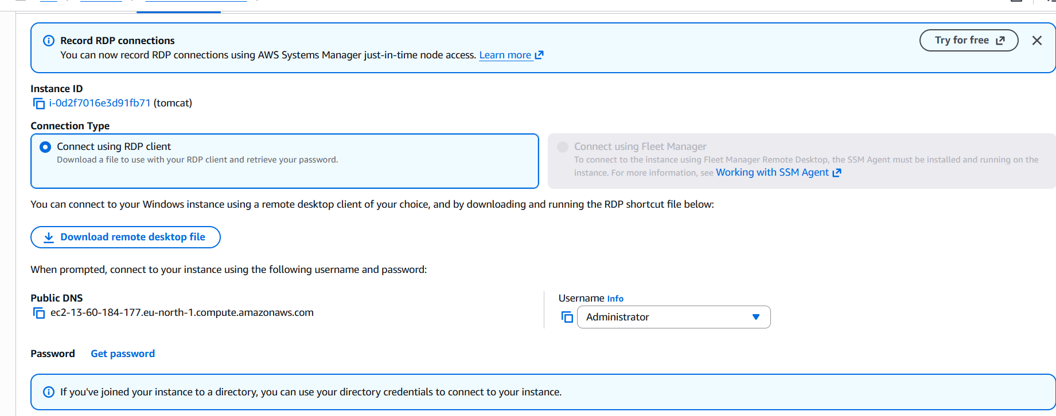
Adding the rules RDP 3389
After that copying pawword and adding pemkey
Install the java and check the version in cmd
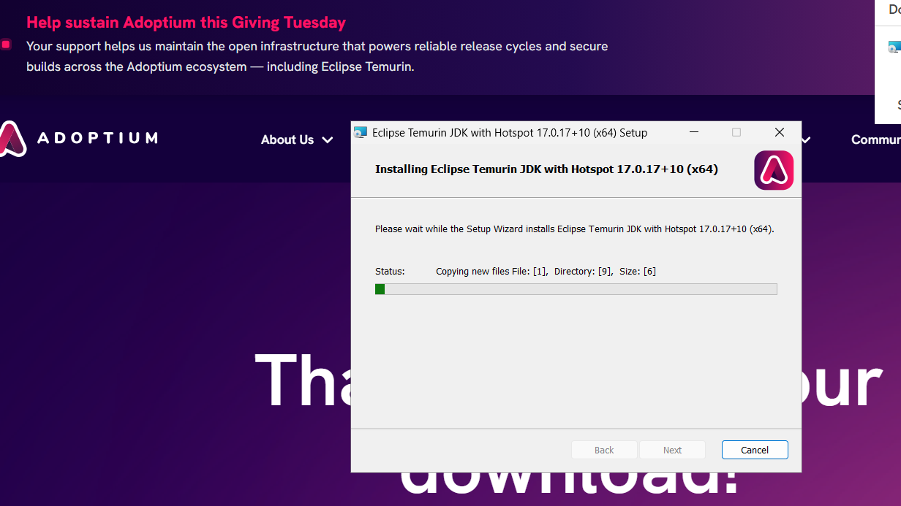

Throw this website I install the java

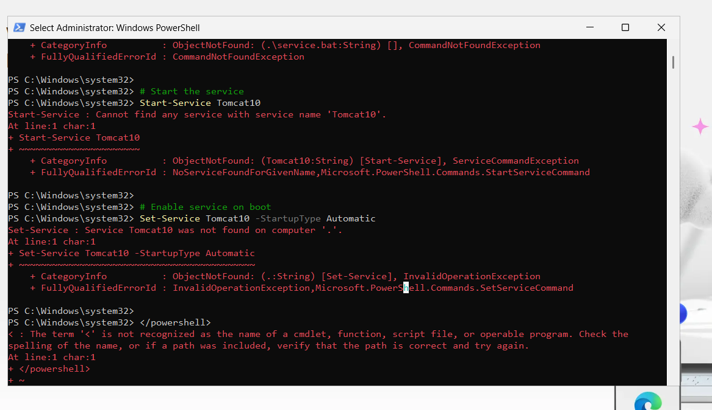
I tried in powershell but its is not install after that movine too
Moving to windows remote server
In that windows remote server I install the apahe tomcat
Checking in remote server its working
And go to local and check with ip adderess

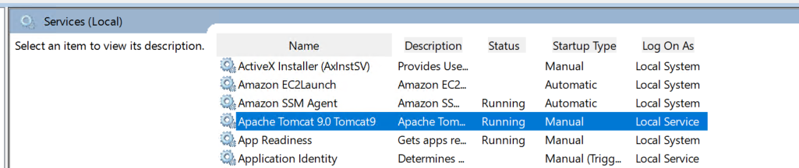

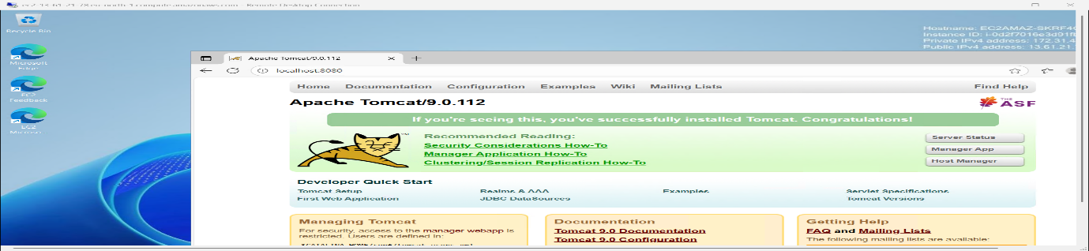

- Take a snapshot of the instance created in Task 1.
Got to ebs values in that snapshot on that
→ Actions → Create snapshot.
Create snapshot.
EC2 → Elastic Block Store → Snapshots
Actions → Create Volume from the snapshot to restore, or Actions → Copy to copy to another region.

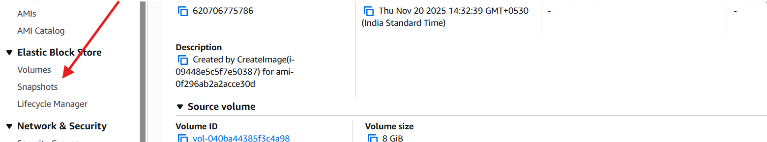
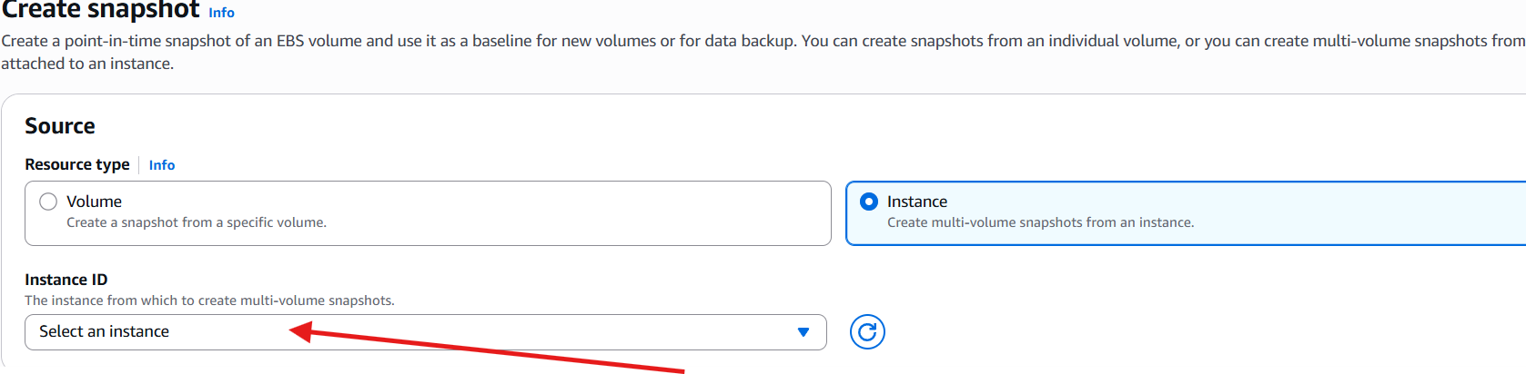

- .Assign passwordless authentication for the EC2 created in Task 2.

First set the publickey for that
Ssh -i (pemkeyname).pem ubutu@ec2
(copy the publicid)
Cat ( publicid) copy the pemkey
Again (shh -I pemkeyname.pem) ubutu@ec2
Cd .ssh
Authozied key
Vi authozied key
Past the publichkey
Save
Exit form instances
Now connected instances without using pemkey

ssh-keygen
(path pub)
Cat (path pub)
$ ssh -i "firstserver.pem" ubuntu@ec2-13-60-80-107.eu-north-1.compute.amazonaws.com
Remove the pemkey
$ ssh ubuntu@ec2-13-60-80-107.eu-north-1.compute.amazonaws.com

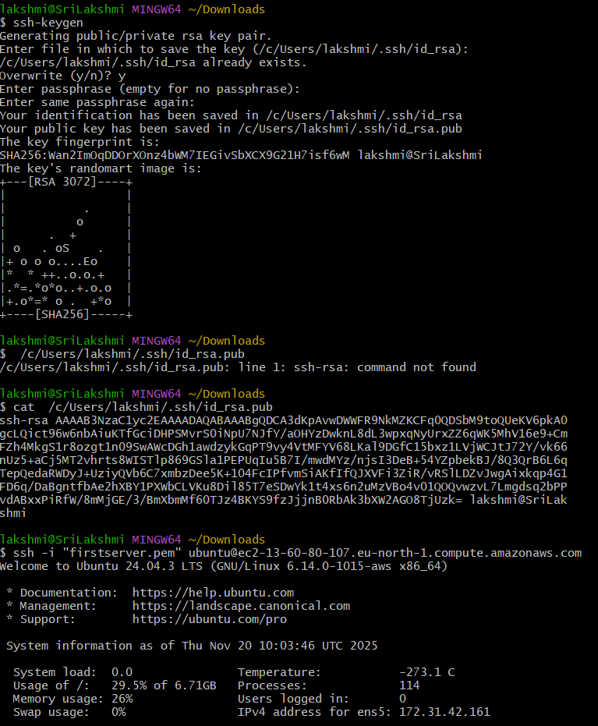
q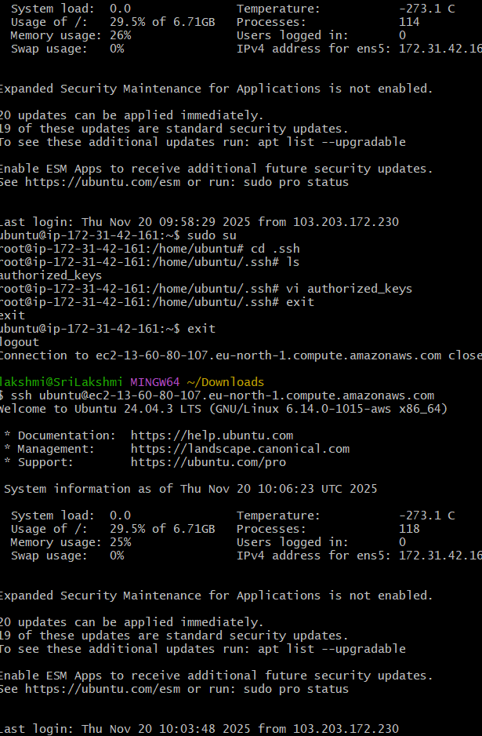

6.Launch any EC2 using the spot purchasing option.

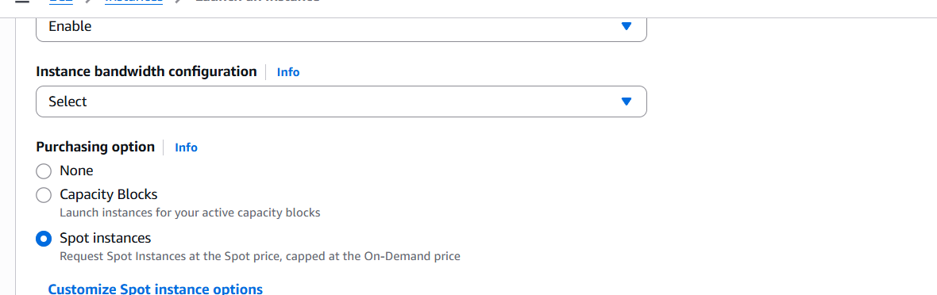
Launch ec2 instance
Got to advanced details
Purchasing options
Seleted the options
(spot instance)

7. Enable termination policy on the EC2 created in Task 2.
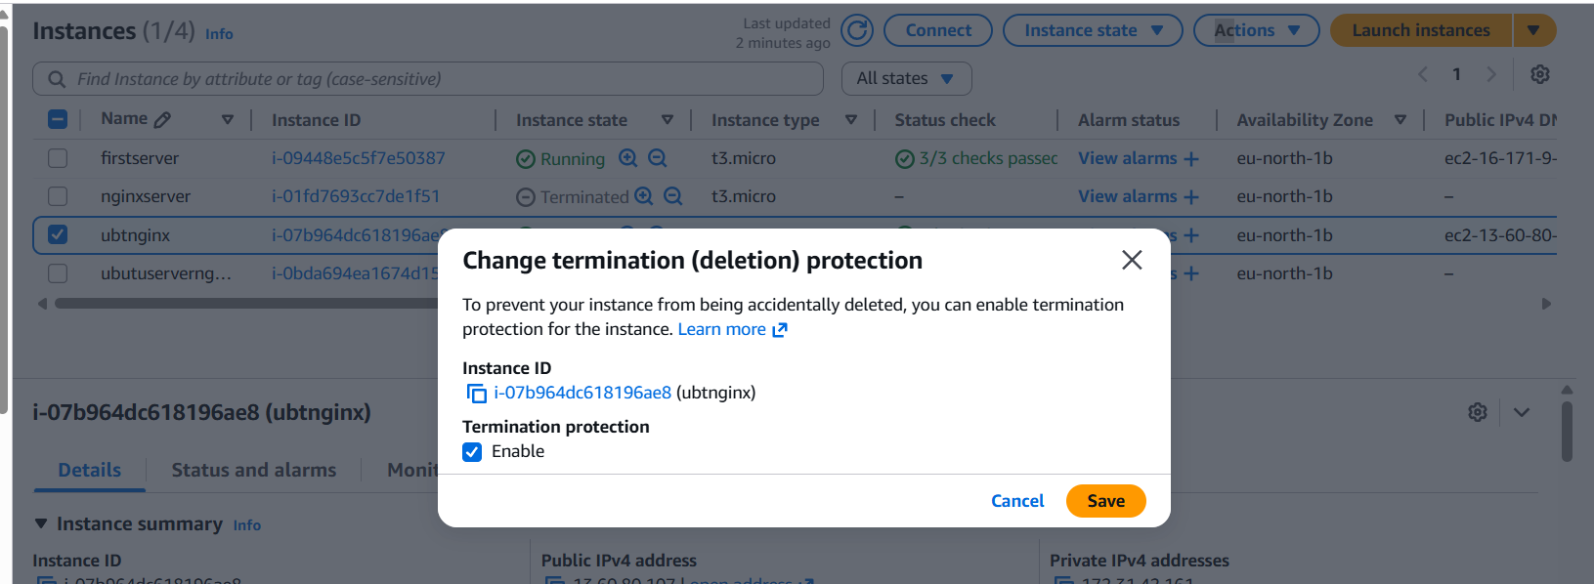
Sign in to the AWS Console and open EC2 → Instances.
find and select the instance you want to protect
click the Instance state / Instance settings drop-down
Click Change termination protection
Enable and save

8.Launch one EC2 using AWS CLI.
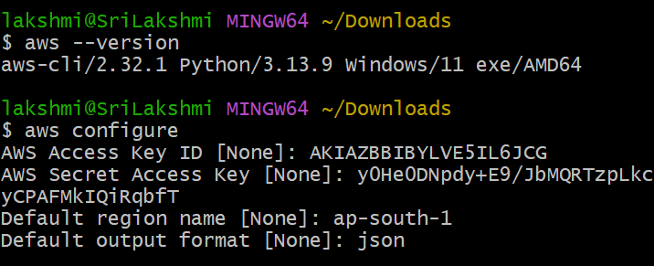
aws ec2 create-key-pair --key-name sreekey --query 'KeyMaterial' --output text > sreekey.pem using this command create a name
aws ec2 create-security-group --group-name sreee --description "My sree security group" usig this command group is created
add port number 22 to the created serurity group
aws ec2 authorize-security-group-ingress --group-name sreee --protocol tcp --port 22 --cidr 0.0.0.0/0 this is form port number changes

Luch the instances

